

**Project Title**

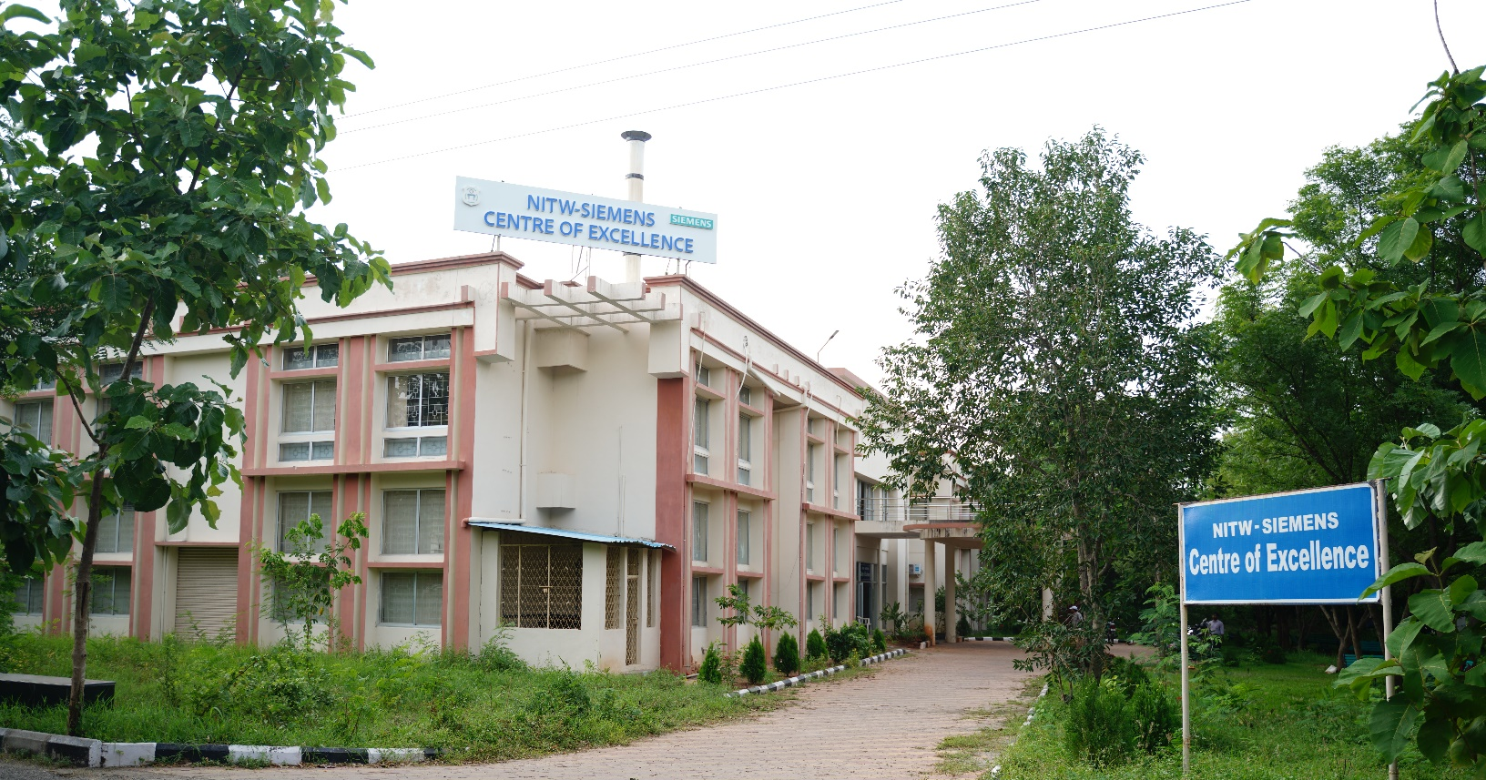

**National Institute of Technology, Warangal**

**Centre of Excellence for Digital Manufacturing and Automation**

(A Joint Initiative of NIT Warangal and Siemens)

Hanamkonda, Telangana, 506004, India.

May 2024

**Abstract**

**(Font Size 20; Style – Times New Roman; Bold)**

An abstract is a concise summary of a larger work, such as a research paper, thesis, conference presentation, or book. It provides a brief overview of the main points, including the purpose (Aim or Objective), methodology, results, and conclusions of the work. Typically ranging from 150 to 300 words. Content to be in this format (Font Size -16; Style – Times New Roman)

**Project Members**

1. Name, Roll No, Department, College
2. Name, Roll No, Department, College
3. Name, Roll No, Department, College

**Submitted to**

Y. Yasmeen Mirza,

Centre Manager,

CoE for DM and Automation, NITW.

**Table of Content**

1. **Introduction**
2. **Literature Survey**
3. **Methodology**
4. **Resources Utilized (Software /Hardware Details)**
5. **Experiment Details (Procedure)**
6. **Results (Picture, graphs, tables etc)**
7. **Conclusion**
8. **References**

**Sub Headings (Font Size – 16; Style – Times New Roman; Bold)**

All Content (Font Size – 14; Style – Times New Roman)

Titles for Graphs and table (Font Size – 10; Style – Times New Roman)